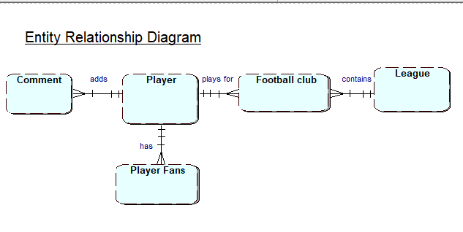
Erd

Table Types
Player(playerID firstName, lastName, DOB, position, goals, assists, yellow cards, red cards)
PlayerFans(playerFansID, playerID, userID)
FootballClub(footballclubID,clubname, club goals, passes, cleansheets, leagueID)
League(leagueID, league name, description,seasons)
Comments(commentID, rating, date, playerID, userID)

